BEAUFORT-WES(T)
MUNISIPALITEIT // MUNICIPALITY

LAND USE PLANNING PRE-APPLICATION CONSULTATION FORM

KINDLY NOTE:
Pre-application consultation is an advisory session and does not in any way pre-empt the outcome of any future application which may be submitted to the Municipality.

PART A: PARTICULARS

Reference number: __________________________________________________________________________________

Purpose of consultation: ______________________________________________________________________________

Brief proposal: _______________________________________________________________________________________

Property(ies) description: _____________________________________________________________________________

Date: _______________________________________________________________________________________________

Attendees:
 | Name & Surname | Organisation | Contact Number | E-mail
Official
Pre-applicant
List documents provided for discussion at meeting:
(Include document reference, document/plan dates and plan numbers where possible and attach to this form)

________________________________________________________________________________________________________________________________________________________________________________________________________________________________________________________________________________________________________________________________________________________________________________________________________________________________________________________________________________________________________________________

YES | NO
Has pre-application consultation been undertaken for a land development application in terms of section 53 of the Western Cape Land Use Planning Act, 2014 (Act 3 of 2014) (LUPA) and regulation 10 of the Western Cape Land Use Planning Regulations, 2015 (LUP regulations)?
(If yes, request a copy of the minutes)

Comprehensive overview of proposal:

_________________________________________________________________________________________________________________________________________________________________________________________________________________________________________________________________________________________________________________________________________________________________________________________________________________________________________________________________________________________________________________________________________________________________________________________________________________________________________________________________________________________________________________________________________________________________________________________________________________________________________________________________________________________________________________________________________________________________________________________________________________________________________________________________________________________________________________________________________________________________________________________________________________________________________________________________________________________________________________________________________________________________________________________________________________________________________________________________________________________________________________________________________________________________________________________________________________________________________________________________________________________________________________________________________________________________________________________________________________________________________________________________________________________________________________________________________________________________________________________________________________________________________________________________________________________________________________________________________________________________________________________________________
__________________________________________________________________________________________________________________________________________________________________________________________________________

PART B: APPLICATION PROCESS
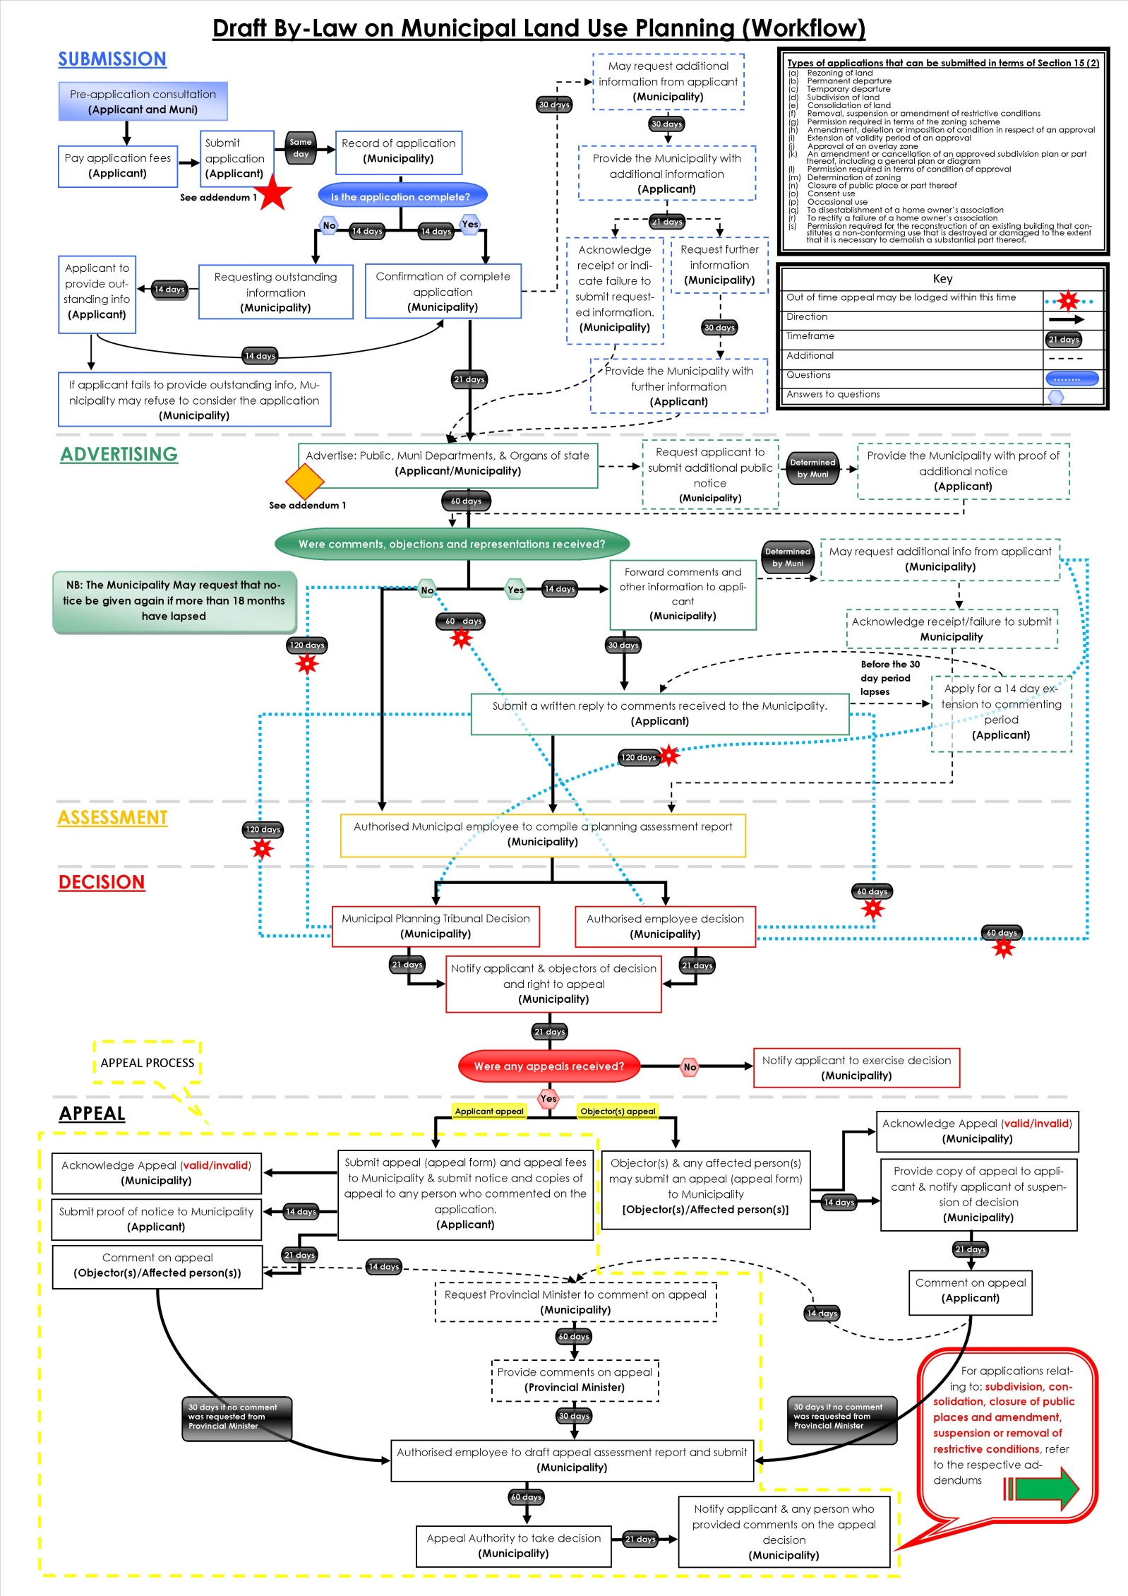

PART C: QUESTIONNAIRES

SECTION A:
DETERMINATION OF APPLICATION TYPES, PRESCRIBED NOTICE AND FEES

Tick if relevant |  | What land use planning applications are required in terms of section 15 of the By-Law on Municipal Land Use Planning for Beaufort West Municipality | Application fees payable
√ | 2(a) | a rezoning of land; | R
√ | 2(b) | a permanent departure from the development parameters of the zoning scheme; | R
√ | 2(c) | a departure granted on a temporary basis to utilise land for a purpose not permitted in terms of the primary rights of the zoning applicable to the land; | R
√ | 2(d) | a subdivision of land that is not exempted in terms of section 24, including the registration of a servitude or lease agreement; | R
√ | 2(e) | a consolidation of land that is not exempted in terms of section 24; | R
√ | 2(f) | a removal, suspension or amendment of restrictive conditions in respect of a land unit; | R
√ | 2(g) | a permission required in terms of the zoning scheme; | R
√ | 2(h) | an amendment, deletion or imposition of conditions in respect of an existing approval; | R
√ | 2(i) | an extension of the validity period of an approval; | R
√ | 2(j) | an approval of an overlay zone as contemplated in the zoning scheme; | R
√ | 2(k) | an amendment or cancellation of an approved subdivision plan or part thereof, including a general plan or diagram; | R
√ | 2(l) | a permission required in terms of a condition of approval; | R
√ | 2(m) | a determination of a zoning; | R
√ | 2(n) | a closure of a public place or part thereof; | R
√ | 2(o) | a consent use contemplated in the zoning scheme; | R
√ | 2(p) | an occasional use of land; | R
√ | 2(q) | to disestablish a home owner’s association; | R
√ | 2(r) | to rectify a failure by a home owner’s association to meet its obligations in respect of the control over or maintenance of services; | R
√ | 2(s) | a permission required for the reconstruction of an existing building that constitutes a non-conforming use that is destroyed or damaged to the extent that it is necessary to demolish a substantial part of the building. | R
Tick if relevant |  | What prescribed notice will be required? | Advertising fees payable
Y | N | Serving of notices (i.e Delivering by hand; registered post; data messages)  Publication of notices (i.e Local Newspaper(s); Provincial Gazette; site notice; Municipality’s website) | R
Y | N | Additional publication of notices (i.e Site notice, public meeting, local radio station, Municipality’s website, letters of consent or objection) | R
Y | N | Notice of decision (i.e Provincial Gazette) | R
Y | N | Integrated procedures | R
TOTAL APPLICATION FEE*: |  |  | R

KINDLY NOTE: * Application fees are estimated on the information discussed and are subject to change with submission of the formal application.
Application fees that are paid to the Municipality are non-refundable and proof of payment of the application fees must accompany an application.
The applicant is liable for the cost of publishing and serving notice of an application.

SECTION B:
PROVISIONS IN TERMS OF THE RELEVANT PLANNING LEGISLATION / POLICIES / GUIDELINES

QUESTIONS REGARDING PLANNING POLICY CONTEXT | YES | NO | TO BE DETERMINED | COMMENT
Is any municipal integrated development plan, spatial development framework(s), structure plans, by-laws or any other municipal policies or guidelines applicable? If yes, is the proposal in line with the aforementioned documentation/plans?
Any applicable restrictive condition(s) prohibiting the proposal? If yes, is/are the condition(s) in favour of a third party(ies)? [List condition numbers and third party(ies)]
Any other Municipal by-law that may be relevant to application? (If yes, specify)
Zoning Scheme By-law considerations:
What is the current zoning of the property?
__________________________________________________________________________________
What is the proposed zoning of the property?
__________________________________________________________________________________
Does the proposal fall within the provisions/parameters of the zoning scheme?
__________________________________________________________________________________
Are additional applications required to deviate from the zoning scheme? (if yes, specify)
__________________________________________________________________________________

QUESTIONS REGARDING OTHER PLANNING CONSIDERATIONS | YES | NO | TO BE DETERMINED | COMMENT
Is a development application affecting national interest in terms of section 52(3) of Spatial Planning Land Use Management Act, 2013 (Act 16 of 2013) (SPLUMA), required?
Is the proposal in line with the national spatial development framework and national laws, regulations, other guidelines or documents?
Is the proposal in line with the principles for land development, set out in the SPLUMA and the Western Cape Land Use Planning Act, 2014 (Act 3 of 2014)?
Is the proposal in line with the provincial spatial development framework(s) and provincial laws, regulations, other policies, guidelines or documents?
Is any district municipal integrated development plan, spatial development framework, other policies, guidelines or documents relevant?

SECTION C:
CONSENT / COMMENT REQUIRED FROM OTHER ORGANS OF STATE

OUESTIONS REGARDING CONSENT / COMMENT REQUIRED | YES | NO | TO BE DETERMINED | OBTAIN APPROVAL / CONSENT / COMMENT FROM:
Is a land development application required in terms of section 53(2) of LUPA or section 10 of LUP Regulations? |  |  |  | Western Cape Provincial Department of Environmental Affairs & Development Planning (DEA&DP)
Is provincial comment on land use application(s) required in terms of section 45(1) of LUPA? |  |  |  | DEA&DP
Is/was the property(ies) utilised for agricultural purposes? |  |  |  | Western Cape Government Department of Agriculture
Will the proposal require approval in terms of Subdivision of Agricultural Land Act, 1970 (Act 70 of 1970)? |  |  |  | National Department of Agriculture, Forestry and Fisheries (DAFF)
Will the proposal trigger a listed activity in terms of National Environmental Management Act, 1998 (Act 107 of 1998) (NEMA)? |  |  |  | DEA&DP
Will the proposal require authorisation in terms of Specific Environmental Management Act(s) (SEMA)?  (National Environmental Management: Protected Areas Act, 2003 (Act 57 of 2003) (NEM:PAA) /  National Environmental Management: Biodiversity Act, 2004 (Act 10 of 2004) (NEM:BA) /  National Environmental Management: Air Quality Act, 2004 (Act 39 of 2004) (NEM:AQA) /  National Environmental Management: Integrated Coastal Management Act, 2008 (Act 24 of 2008) (NEM:ICM) /  National Environmental Management: Waste Act, 2008 (Act 59 of 2008) (NEM:WA)  (strikethrough irrelevant) |  |  |  | National Department of Environmental Affairs (DEA) &  DEA&DP
Will the proposal require authorisation in terms of the National Water Act, 1998 (Act 36 of 1998)? |  |  |  | National Department of Water & Sanitation (DWS)
Will the proposal trigger a listed activity in terms of the National Heritage Resources Act, 1999 (Act 25 of 1999)? |  |  |  | South African Heritage Resources Agency (SAHRA) & Heritage Western Cape (HWC)
Will the proposal have an impact on any National or Provincial roads? |  |  |  | National Department of Transport / South Africa National Roads Agency Ltd. (SANRAL) & Western Cape Department of Transport and Public Works (DT&PW)
Will the proposal trigger a listed activity in terms of the Occupational Health and Safety Act, 1993 (Act 85 of 1993): Major Hazard Installations Regulations |  |  |  | National Department of Labour (DL)
Will the proposal affect any Eskom owned land and/or servitudes? |  |  |  | Eskom
Will the proposal affect any Telkom owned land and/or servitudes? |  |  |  | Telkom SA Ltd.
Will the proposal affect any Transnet/Passenger Rail Agency of South Africa owned land and/or servitudes? |  |  |  | Transnet/PRASA
Is the property subject to a land / restitution claim(s)? |  |  |  | National Department of Rural Development & Land Reform
Will the proposal require comments from South African National Parks (SANParks) and/or CapeNature? |  |  |  | SANParks / CapeNature
Is the property subject to any existing mineral rights? |  |  |  | National Department of Mineral Resources
Does the proposal lead to densification to such an extent that the number of schools, healthcare facilities, libraries, safety services, etc. In the area may be impacted on?  (strikethrough irrelevant) |  |  |  | Western Cape Government Departments of Cultural Affairs & Sport,  Education, Social Development,  Health and Community Safety
Does the proposal require any other authorisation(s) in terms of other applicable legislation that is not listed in the subject table? |  |  |  | If yes, specify

SECTION D:
SERVICE REQUIREMENTS

DOES THE PROPOSAL REQUIRE THE FOLLOWING ADDITIONAL INFRASTRUCTURE / SERVICES? | YES | NO | TO BE DETERMINED | OBTAIN COMMENT FROM:  (list internal department)
Electricity supply:

Water supply:

Sewerage and waste water:

Stormwater:

Road network:

Telecommunication services:

Other services required? Please specify.

Development charges:

PART D: ATTACHMENTS AND SUPPORTING INFORMATION AND DOCUMENTATION FOR LAND USE PLANNING APPLICATION

Information and documentation required in terms of section 38(1) of the By-Law on Municipal Land Use Planning for Beaufort West Municipality

Completed and signed application form |  |  |  |  | Bondholder’s consent (if applicable)
Power of attorney / Owner’s consent if applicant is not owner |  |  |  |  | Proof of registered ownership or any other relevant right held in the land concerned
Resolution or other proof that applicant is authorised to act on behalf of a juristic person |  |  |  |  | S.G. diagram / General plan extract
Written motivation |  |  |  |  | Site development plan or conceptual layout plan
Locality plan |  |  |  |  | Proof of agreement or permission for required servitude
Proposed subdivision plan |  |  |  |  | Full copy of the title deed
Proof of payment of application fees |  |  |  |  | Minutes of pre-application consultation meeting (if applicable)
Conveyancer’s certificate
Supporting information and documentation:

Y | N | N/A | Consolidation plan |  | Y | N | N/A | Land use plan / Zoning plan
Y | N | N/A | Street name and numbering plan
Y | N | N/A | Landscaping / Tree plan |  | Y | N | N/A | 1 : 50 / 1:100 Flood line determination (plan / report)
Y | N | N/A | Abutting owner’s consent |  | Y | N | N/A | Home Owners’ Association consent
Y | N | N/A | Copy of Environmental Impact Assessment (EIA) /  Heritage Impact Assessment (HIA) /  Traffic Impact Assessment (TIA) / Traffic Impact Statement (TIS) /  Major Hazard Impact Assessment (MHIA) /  Environmental Authorisation (EA) / Record of Decision (ROD)  (strikethrough irrelevant) |  | Y | N | N/A | Services Report or indication of all municipal services / registered servitudes
Y | N | N/A | Copy of original approval and conditions of approval |  | Y | N | N/A | Proof of failure of Home owner’s association
Y | N | N/A | Proof of lawful use right |  | Y | N | N/A | Any additional documents or information required as listed in the pre-application consultation form / minutes
Y | N | N/A | Required number of documentation copies |  | Y | N | N/A | Other (specify)

PART E: DISCUSSION

__________________________________________________________________________________________________________________________________________________________________________________________________________
_______________________________________________________________________________________________________________________________________________________________________________________________________________________________________________________________________________________________________________
_____________________________________________________________________________________________________
____________________________________________________________________________________________________________________________________________________________________________________________________________________________________________________________________________________________________________________________________________________________________________________________________________________
__________________________________________________________________________________________________________________________________________________________________________________________________________
__________________________________________________________________________________________________________________________________________________________________________________________________________

PART F: SUMMARY / WAY FORWARD

__________________________________________________________________________________________________________________________________________________________________________________________________________
_______________________________________________________________________________________________________________________________________________________________________________________________________________________________________________________________________________________________________________
_____________________________________________________________________________________________________
____________________________________________________________________________________________________________________________________________________________________________________________________________________________________________________________________________________________________________________________________________________________________________________________________________________
__________________________________________________________________________________________________________________________________________________________________________________________________________
__________________________________________________________________________________________________________________________________________________________________________________________________________
_______________________________________________________________________________________________________________________________________________________________________________________________________________________________________________________________________________________________________________
_____________________________________________________________________________________________________

OFFICIAL: _______________________________ PRE-APPLICANT: ______________________________________ (FULL NAME) (FULL NAME)

SIGNED: _______________________________ SIGNED: _____________________________________

DATE: ______________________________ DATE: _______________________________________

