- TOWARDS A CAPITAL EXPENDITURE FRAMEWORK FOR BEAUFORT WEST
CHAPTER 5: TOWARDS A CAPITAL EXPENDITURE FRAMEWORK FOR BEAUFORT WEST
Section 21(n) of SPLUMA requires that municipal spatial development frameworks “determine a capital expenditure framework for the municipality’s development programmes, depicted spatially”. The intention is to more effectively link the municipality’s spatial development strategies to one of the primary means with which to implement these strategies, namely the municipality’s budget. By providing more specific guidance on what investments should be made where, in what order of priority, alignment between the Municipality’s strategies, plans and policies and development on the ground is better maintained and the risk that budget allocations undermine or contradict the MSDF are mitigated.
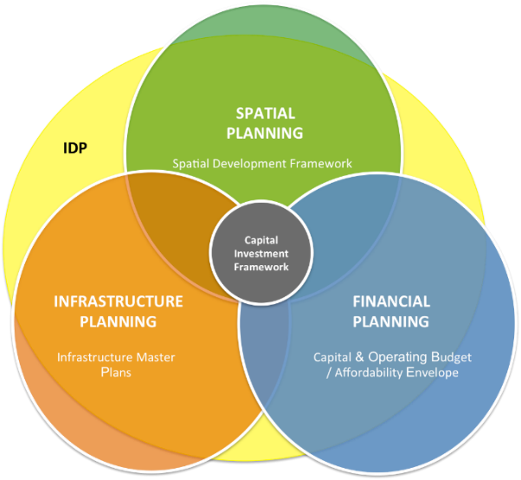
Figure 5.1: The Capital Expenditure Framework as the meeting point between Spatial Planning, Infrastructure Planning and Financial Planning (Knysna, 2019)

Based on this, spatial categories for investment planning are presented to guide the investment approach and strategy of the municipality, as well as an agreed approach to future development in the municipality towards municipal financial sustainability.

  - WHAT IS A CEF?
Ideally, the infrastructure and built environment programmes articulated in the 5-year Integrated Development Plan should find their origins in the MSDF (Municipal Spatial Development Frameworks), which is a 20-year plan for the management of the physical growth and development of the municipality. Annual assessments of municipal IDP’s undertaken by Province have shown a poor linkage between the spatial strategies and proposals articulated in MSDF’s, and the location of budgeted infrastructure and built environment programmes within municipalities. This misalignment between budget allocation and municipal plans is fundamentally problematic and must urgently be addressed.
The CEF offers a mechanism through which the municipality’s long-term strategic development vision truly directs infrastructure implementation whilst remaining conscious of the municipality’s financial position and infrastructure planning needs. In creating the link between finance, spatial planning, and the infrastructure/technical department of a municipality, the CEF creates a golden thread, that runs from the municipality’s long-term strategic development vision, sector planning, through the budget allocation process to implementation. In this way infrastructure spending should progressively realise the strategic vision of the municipality.
This CEF therefore provides an integrated, strategy-aligned, plan-aligned, prioritized and financially affordable portfolio of capital investments for the municipality, over a 10-year period, that must be used as a key informant to the annual budgeting process of the municipality. Alignment of municipal capital budgets to the CEF will demonstrate, therefore, alignment of the budget to the municipality's plans and strategies.

  - THE PROCESS AND METHOD TO DEVELOP THE CEF
The development of a CEF is an inherently inter-disciplinary process that requires the participation and input of all municipal departments. The development of a CEF followed 5 distinct phases, as set out in Figure 4 below. These phases are:
- Phase 1: Information Gathering and consolidating of capital investments into a consolidated database.
- Phase 2a: Profiling the functional areas and determining the land demand forecasts based on new growth and backlog.
- Phase 2b: Translating growth into capital investment needs.
- Phase 3: Defining the affordability envelop as per the LTFP.
- Phase 4: Developing prioritisation criteria that articulate municipal strategy.
- Phase 5: Prioritization of capital investments needed, sequence and fit within affordability envelop.

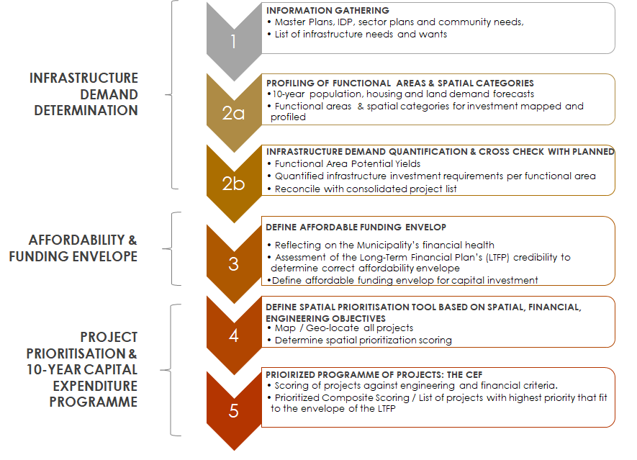
  - PHASE 1: THE CONSOLIDATED PORTFOLIO OF CAPITAL INVESTMENT NEEDS
This consolidated database of capital investment needs is the basis upon which the prioritised portfolio of capital investments will be developed. The output of phase 1 is a consolidated table of infrastructure investments (new, upgrade or maintenance) per infrastructure type, per functional area, for the entire municipality, which is shown in the technical report and associated databases, a screen shot of which is shown below.

  - PHASE 2: FUNCTIONAL AREAS AND SPATIAL CATEGORY FOR INVESTMENT PLANNING PROFILING

    - SPATIAL CATEGORIES FOR INVESTMENT PLANNING
There are three spatial categories identified for guiding investment planning both at the municipal-wide scale and the settlement scale in order to align investment to the SDF’s strategies.

PRIORITY INVESTMENT AREAS

Priority Investment Areas at the municipal-wide scale: This is referring to the town of Beaufort West that is within an Arid Innovation Region and regarded as a Regional Development Anchor at a regional context. The town generally occupies a high order in terms of the services, facilities and employment opportunities that are on offer, and also generally with the largest population size, and greatest social need and economic growth potential within the region. Generally, investments made in this settlement will have the greatest multiplier effect and impact on the greatest number of people.

Priority Investment Areas at the settlement scale: These are the principal transport activity corridors (NI, N12) and the Beaufort West CBD, the secondary nodes and priority public transport-oriented development nodes connected by the corridors. This area is also defined by a restructuring zone which seeks to reinforce the centre. These areas must be the focus for getting the basics right as well as adding value through new investment to facilitate social inclusion, attract economic activity and private sector and household investment. There is scope for the absorption of residential, commercial, and industrial growth within this zone. These areas and the priority nodes specifically should be the focus of any municipal investment incentives including expedited land use development procedures and/or relaxation of development controls; e.g. parking requirements. This should be done in a way that creates a public realm and streetscape that must keep intact and enhance the integrity of the Klein Karoo identity and attractiveness.

UPGRADING AREAS

Upgrading areas at the municipal-wide scale: These are the settlements that still have considerable populations, services, and some job opportunities, but that are not seen as primary service centres at the regional scale. They are generally major rural settlements that play a role in the economy of the region, but also with pressing social needs. Further significant expansion of these areas not advised. The upgrading area within the Beaufort West municipal area is Murraysburg.

Upgrading areas at the settlement scale: These are areas primarily focussed on informal settlement and marginalised rural settlements and areas that require upgrading and improvement to bring them to an acceptable standard of performance as residential settlements.

CONSOLIDATION AREAS
Consolidation areas at the settlement and municipal-wide scale forms the balance of the settlement footprint. In these areas the focus is to ensure the provision and maintenance of services so that the area may perform well within their current functions with no further expansion or growth of these areas, as far as possible. These include settlements such as Merweville and Nelspoort.

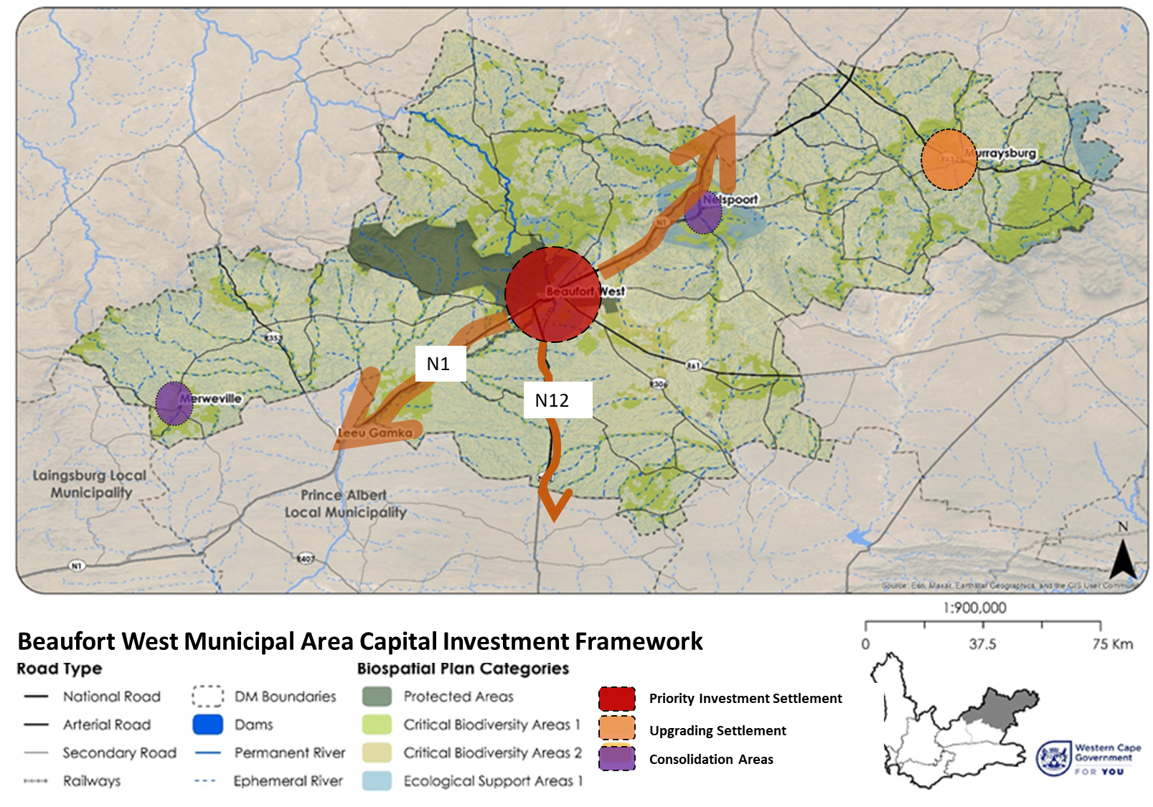
Figure 5.2: Beaufort West Municipal Area Capital Expenditure Framework map

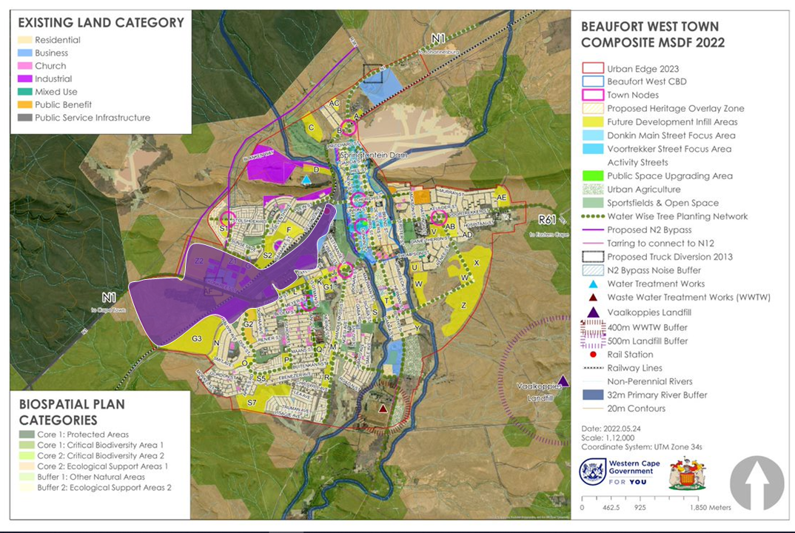
Figure 5.3: NB: THIS IS A PLACEHOLDER MAP FOR THE CEF MAP FOR BEAUFORT WEST MUNICIPAL AREA

    - FUNCTIONAL AREAS

Functional Areas are areas of similar characteristics, service levels and have similar service requirements, such as low density established suburbs, industrial areas, high density informal areas or central business districts. These areas usually correspond to an area sharing the same engineering and utility service requirements and levels of service (or have similar upgrading needs).
The following functional areas were identified:
- Functional Area 1: Middeldorp / Beaufort West Central Business District;
- Functional Area 2: Kwa-Mandlenkosi & Rustdene;
- Functional Area 3: Beaufort West Industrial Park and future industrial area;
- Functional Area 4: Hillside
- Functional Area 5: Beaufort West East / Hospital Hill
- Functional Area 6: Merweville
- Functional Area 7 Murraysburg
- Functional Area 8 Nelspoort
- Functional Area 9 Beaufort West rural
Once each functional area was defined, a household analysis was undertaken both for the year 2023, as well as a projected household analysis for the year 2033 per functional area, as shown below, using high average growth rate projections.
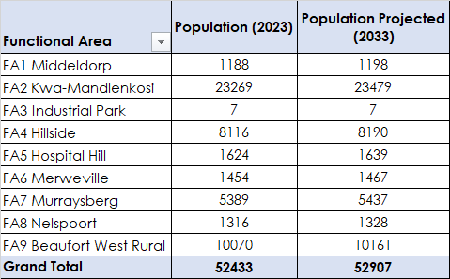

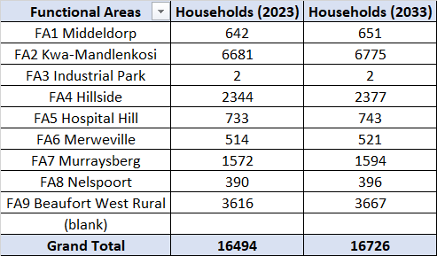

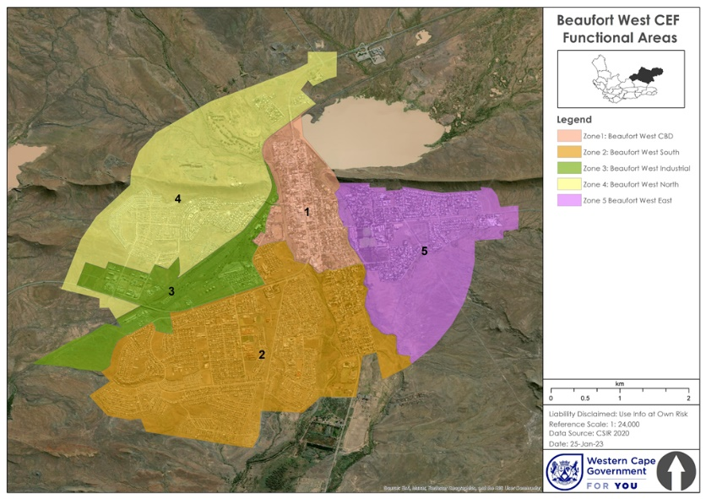

  - FINANCIAL PLANNING INFORMANTS
Figure 5.4, below, illustrates the point that generally speaking – and indeed in the case of Beaufort West municipality – infrastructure investment need generally exceeds available capital finance. It is therefore imperative for the municipality to undertake a prioritisation process to determine that which is affordable.
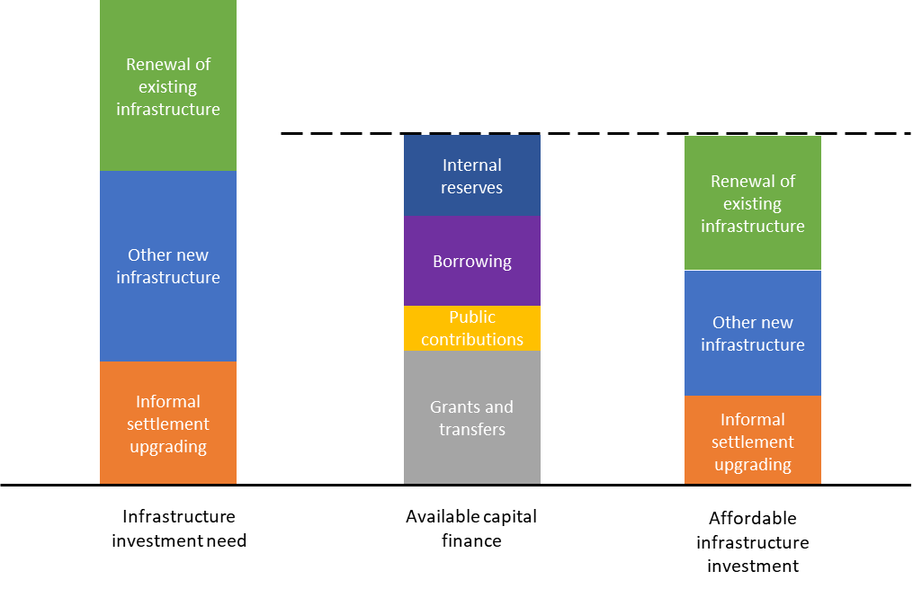
Figure 5.4: The Capital Expenditure Framework assists in determining what is affordable, within the ‘affordability envelope’ that is set out in the Long-Term Financial Plan (Knysna, 2019)

The municipality does not currently have a Long-Term Financial Plan which provides an overview on various measures that describe the municipality’s financial health, spending and revenue, which go beyond its multi budget annual cycles (i.e. MTREF) and multi-year capital plan. Annexure B illustrates that despite Beaufort West’s overall financial health indicators showing a gradual improvement between 2017 and 2021.
The Financial Recovery Plan (2022) for Beaufort West indicates that the municipality has the following historical expenditure and forecast expenditure for the capital budget going forward:
- R78 600 000 in 2017/18
- R8 891 000 in 2018/19
- R22 792 000 in 2019/20
- R56 206 000 in 2020/21
- R11 108 000 in 2021/22
- R11 044 000 in 2022/23
- R8 527 000 in 2023/24

This highlights the critical importance of spending capex extremely wisely and strategically in addressing Beaufort West’s development challenges.

  - ENGINEERING & INFRASTRUCTURE PLANNING INFORMANTS
As has been illustrated in Chapter 4 and the financial health indicators of the municipality from the MTREF, PERO, IDP and the Financial Recovery Plan for Beaufort West, the municipality is currently not on a sustainable financial footing from an infrastructure maintenance and upgrade perspective, and that it is battling to maintain some of its existing infrastructure network, without even considering expansion of this network. It is from this perspective that the municipality should develop policies that seek to focus on utilising its current infrastructure asset network more cost-effectively and prevent costly outward urban expansion of this network.
The following factors are worth noting from an infrastructure backlogs and planning perspective:

- The existing Landfill Sites which require regular maintenance and/or upkeeping.
- The existing conditions of all the roads within the municipality need maintenance.
- The development and maintenance of existing NMT routes within all the settlements in Beaufort West.
- Water and sanitation infrastructure maintenance.

The following are key questions that will need to be answered fully, following the updates of the relevant engineering masterplans, which are largely outdated, as well as Financial Strategy which should detail:
- Where is sewer / water / roads and storm water infrastructure failing / under pressure?

- How much will it cost to address failing infrastructure and infrastructure need maintenance?

- How much money is available to address failing infrastructure and infrastructure needing maintenance?

- What is the planned new infrastructure on the books?

- Is the municipality meeting the minimum requirement of % of spending on repairs and maintenance (8%)?

- What new connection needs does the municipality need to action?

- What are affordable development options vs. unaffordable development options?

- What is deemed to be revenue generating infrastructure vs. non-revenue generating infrastructure?

- What is the strategy to transition areas / neighbourhoods from ‘indigent’ neighbourhoods to ‘service paying’ neighbourhoods over time? Inherent to this question is what is the municipality’s strategy to achieve municipal financial sustainability over time?
The above questions will inform a more nuanced and spatially specific Capital Expenditure Framework for Beaufort West.

  - INFORMING PRIORITIES AND INFRASTRUCTURE DEVELOPMENT APPROACH
The infrastructure systems of Beaufort West municipality in general present growth inhibiting challenges due to the fact that infrastructure is aging, generally under-maintained with backlogs and supply ceilings being reached. The municipality needs to focus its energies on infrastructure maintenance and infrastructure upgrading (of existing infrastructure systems and networks). Only in rare instances should the municipality pursue infrastructure expansion, and only in terms of the parameters outlined in the Urban Growth Proposals Assessment Framework in Annexure A of this document.
Priority spending and efforts should be placed on infrastructure maintenance and upgrading rather than on infrastructure network expansion. Maintenance of existing infrastructure and existing assets is first and foremost the priority of the municipality, and specifically within the town of Beaufort West as the priority followed by Murraysburg, Merweville and Nelspoort;
Optimising the use of existing infrastructure systems must be prioritised as well. This means actively increasing densities within the existing footprint of the municipality, specifically in the middle- and upper-income areas, to moderately increased densities. Outward expansion will be assessed against the Beaufort West’s Growth Proposals Assessment Framework (see Annexure A).

  - NEXT STEPS TO FINALISE A CEF
The following remains to be done in order to develop a comprehensive Capital Expenditure Framework for Beaufort West Municipality:

- Phase 2a which is to understand the potential yield of t eland available for future urban development and reconciling it with the projected household growth until 2030.

- Tabulate and map all infrastructure master plan maintenance and expansion projects that have been proposed for the next 10 years, ascertaining the infrastructure proposals for each zone and priority development areas. Determine investment requirements per functional area as a draft Capital Investment Framework, determine the operational and maintenance expenditure per asset class, per functional area.

- Reflect on the Long-Term Financial Plan, and the ability of the municipality to fund it’s the infrastructure maintenance and expansion programmes into the future.

- Prioritise, map, sequence and determine funding for all infrastructure projects, based on the extent to which they achieve the MSDF objectives.

- Finalise a prioritised Capital Expenditure Framework by developing and applying a prioritisation framework and present a final spatial analysis of the CEF.

CHAPTER 6: IMPLEMENTATION FRAMEWORK
- IMPLEMENTATION FRAMEWORK

The purpose of this implementation framework is to set out the various implementation requirements of the Beaufort West SDF, primarily focusing on:
- Determining the functional areas of the municipality through which the SDF can be implemented;
- Setting out the institutional arrangements for the implementation of the SDF;
- Providing concise inputs into municipal sector plans;
- Highlighting the role of the private sector and where partnerships and partnering can be explored as a tool for implementation;
- Set out the local area planning priorities;
- Set out inputs for the municipal budgeting process and the Integrated Development Plan; and
- Highlighting the implementation actions, priorities, and associated time frames for implementation;

It should be noted upfront that the Beaufort West Municipality, as the key administrator of its land use management function, both records the current legal use of land in its zoning scheme, but also can proactively use its land use management system, zoning scheme and rights allocated to various land uses as a means to stimulate or implement various aspects of this SDF that envisage either a change in land use rights, such as the intent to densify a particular area or provide additional rights to a certain land use (such as single residential zoning).

Similarly, the municipality provides various infrastructure delivery, management, maintenance and local service functions such as municipal road network management, water reticulation, wastewater treatment, storm water and electricity reticulation, amongst others. Its infrastructure spending, areas of focus and priorities (both in space, and per programme) can assist in implementing various elements of the SDF. As has been illustrated in the Capital Expenditure Framework section, the infrastructure focus areas and budgets need to be responsive to the proposals as set out in the SDF, as well as affordable as determined by the Long -Term Financial Plan. In this particular instance the Beaufort West Municipality does not have a LTFP.

  - IMPLEMENTATION REQUIREMENTS
SPLUMA requires that MSDF’s include an Implementation Plan that contains the following:
- Sectoral requirements, including budgets and resources for implementation.
- Necessary amendments to the Municipal Zoning Scheme By-Law
- Specification of institutional arrangements necessary for implementation
- Specification of implementation targets, including dates and monitoring indicators; and
- Specification where necessary, of any arrangements for partnerships in the implementation process.

DARD&LR’s SDF Guidelines also guides the implementation framework requirements.

  - INSTITUTIONAL ARRANGEMENTS
The MSDF is a transversal planning instrument – impacting on most, if not all, of the Beaufort West Municipality’s departments as well as the other spheres of government and state-owned entities operating within the municipal area. Institutional alignment is essential to implementing the MSDF.

- The main argument and strategies of the MSDF must be incorporated into Annual Reports, annual IDP Reviews, and future municipal IDPs.
- Any amendment to the MSDF must form part of the IDP review and amendment process.
- The main vision, strategies, proposals, and policies of the MSDF must inform sector planning and resource allocation (refer to 6.3 Inputs into Sector Plans for more detail). In particular, the Municipality’s Human Settlement Plan and Integrated Transport Plan must be led by and aligned to the vision, strategies, proposals, and policies set out in the MSDF.
- The vision, strategies, proposals, and policies of the MSDF must inform land use management decision-making.
- National and provincial plans, programmes, and actions; such as through User Asset Management Plans (in particular for the Health and Education sectors) and Comprehensive Asset Management Plans related to national and provincial assets and facilities, must be guided by the MSDF as they pertain to the Beaufort West Municipality. In particular the development pipelines articulated in the MSDF should be considered in the User Asset Management Plans in terms of adequate social facility provision.
  - INPUTS INTO SECTOR PLANS
The MSDF is a long term, transversal planning and coordination tool and a spatial expression of the Beaufort West Municipality’s vision. While existing Sector Plans give context to the formulation of the MSDF, strategically and spatially, the Sector Plans should be led by the MSDF. To this end, with the adoption of this MSDF for the Beaufort West Municipality, when the Municipality’s Sector Plans are reviewed, the MSDF must be a key consideration or framework for such a review. This is important to ensure alignment and for the sector plans to realise their full potential as implementation tools of the MSDF. The table below summarises the Beaufort West Municipality’s sector plans, their status and implications of the MSDF for these plans. A major issue for aligned planning is a shared understanding of population growth projections and projections of space needed to accommodate this growth. A corporate decision must be made on the most credible numbers which will be the basis for all planning in the Municipality.
Sector Plan | Status & SDF Relationship
Beaufort West Local Integrated Transport Plan 2019 - 2024 | The plan was finalised in 2019 and was prepared for a five-year period. Updates of specific aspects of the plan ought to be undertaken on an annual basis with a specific focus of programmes and budgets.  Although the municipality does not currently have NMT master plan in place, ITP in its current format does include proposed and planned NMT routes for each settlement within the municipality. Needed and there are funds allocated for the implementation of some the projects.  There is a need to gather Gender disaggregated data from surveys on  traveller experiences while cycling, walking and moving around in the district, to give insight about the realities and needs of people navigating between towns.  Gender disaggregated data could analyse why men and women make trips to particular places at a particular time, which will provide a better understanding about functional relationships between settlements and larger towns and assist to respond to the transport needs of the people in a gender responsive manner.
Beaufort West Human Settlement Plan | Future revisions of the Beaufort West Human Settlement Plan must consider the detail in the chapter 4 strategies and policies, specifically strategy two and three. Policy B2 provides settlement hierarchy whilst policy C2 provides Human Settlement Focus Areas for Beaufort West.  Subsidised housing should be located in those settlements where the need is greatest, which have access to an existing array of services and facilities, where there are employment opportunities, and where municipal financial sustainability is not undermined.  Service provision should be affordable for the municipality and on this basis, the extensive expansion of low growth small settlements is discouraged, not only on account of affordability for the municipality, but on the basis that these areas could become pockets of poverty lacking employment prospects, locking people into poverty.
Disaster Management Plan | Future revisions must consider spatial aspects of drought-mitigation and building increased resilience to drought and fire, such as the need to proactively protect valuable water catchment areas from alien vegetation invasion. Riverine systems to be, as far as possible, rehabilitated and aquifer resources and recharge areas to be protected from incompatible land uses.
Climate Change Adaptation Plan | See the entire policy and proposals section of this SDF for implications for Climate Change Adaptation Plan, generally the policies under strategy one and specifically policy A8.
Infrastructure Master Plans
Electricity | In addition to catering for maintenance, and addressing backlogs in access to electricity infrastructure, electrical infrastructure investment should be focused in priority development areas, as shown in the municipal-wide and town-specific maps for Beaufort West in the Capital Expenditure Framework.
Roads  Pavement Management System | Road network and pavement management systems must prioritise the maintenance of existing road networks, and where upgrades and improvements are considered, in conjunction with urban design improvements, priority development areas as dictated by the CEF should guide these decisions.
Water Services Development Plan | Water security is the priority objective for Beaufort West and ensuring secure, consistent supply of water via new water sources.  Future updates must indicate the areas identified in this SDF as needing protection or rehabilitation, such as riverine systems, catchment areas or aquifer recharge areas.
Integrated Waste Management Plan | Ensuring correct management of the existing waste sites, ensuring key management buffers around waste sites are in place, and potential impacts of waste sites on surrounding land uses prevented or mitigated where prevention is not possible.

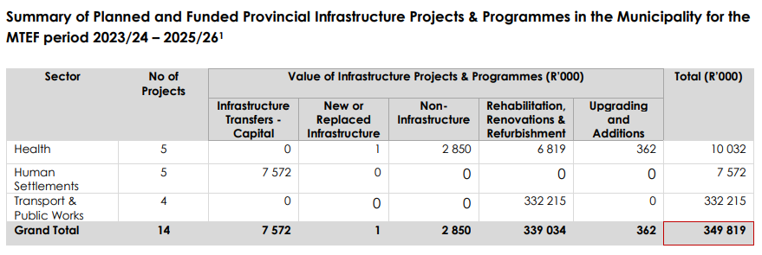
  - PROVINCIAL AND MUNICIPAL EXPENDITURE IN THE DISTRICT (2020/21)
Based on the Overview of Provincial and Municipal Infrastructure Investment (OPMII) Report, 2023, it is anticipated that provincial infrastructure investment for the Beaufort West municipality will amount to R349 819 000 for the 2023/24 – 2025/26 period, which amounts to 71.0% of the budget allocated throughout the entire Central Karoo District. This represents the budgets of the Departments, Health, Human Settlements and Transport and Public Works. It is noted that Education, Social Development and Cape Nature do not have infrastructure investments in Beaufort West municipality during this MTEF period.
Figure 6.1: Provincial Infrastructure Investment Projects in Beaufort West (2023/24 – 2025/26)
The Department of Human Settlements is planning to spend R7 572 000 million on five Infrastructure Transfers – Capital projects and the Department of Transport and Public Works is planning to spend R332 215 000 million on four Rehabilitation, Renovations and Refurbishment projects. The table below, Figure 6.1, shows these projects over the 2023/24 – 2025/26 MTEF.

In terms of allocations from National and Provincial Departments, Figure 6.2 indicates the MTEF allocations that will be made to the Beaufort West Municipality, which is just under R400 million over the MTEF. It should be noted that the equitable share allocation (R249 million over the MTEF), Municipal Infrastructure Grant (R48 million over the MTEF) and Water Services Infrastructure Grant (R28 million over the MTEF) make up the lion’s share of allocations to Beaufort West.
Figure 6.2: Budgeted National and Provincial Allocations in Beaufort West (2022/23 – 2024/25(OPMII, 2022)

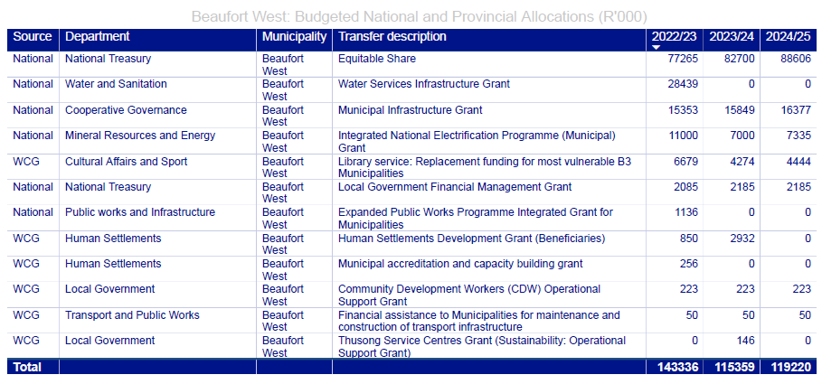

  - IMPLEMENTATION ACTIONS, PRIORITIES & TIMEFRAMES

It should be noted that the actions, priorities and timeframes outlined in the table below are a summary of the actions emanating out of the policies and policy guidelines in Chapter 4, which sets out the strategies, policies and related items to be taken forward.
The municipality will have to undergo a priority-setting exercise, and re-visit this on an annual basis and as part of the IDP review process, to determine if new priorities emerge and if the priorities highlighted below remain priorities or have been implemented.

SPATIAL PLANNING, LAND USE MANAGEMENT AND URBAN DESIGN
Proposal | Approximate Budget | Time Frames | Lead Role-players and funding source
SPLUM 1) To ensure that land use planning decision making is consistent with and congruent with the Biodiversity Spatial Planning Manual and the recommended land use as per the Spatial Planning Categories, adopted within this SDF. | Operational costs – town planning function of Beaufort West municipality | Immediate and ongoing | Beaufort West municipality – town planning  Provincial Department of Environmental Affairs and Development Planning
SPLUM 2) To ensure the integrity of the municipality’s scenic assets by promoting appropriate development typologies and preventing inappropriate development typologies that undermines this character and hence undermines the tourism economy and sense of place.  SPLUM 3) Develop design guidelines for building typologies appropriate in different contexts of the Central Karoo, specifically for Merweville. | Operational costs – town planning department and human settlements department of Beaufort West municipality | Immediate and ongoing | Beaufort West municipality – town planning department  Beaufort West municipality – human settlements department
SPLUM 4) To ensure that all settlements of the municipality are enhanced, made more liveable, more multi-functional, economically vibrant, pedestrian-friendly, landscaped, and beautiful places by the application of the settlement-design principles adopted and promoted in this SDF; | Operational costs – town planning department and human settlements department of Beaufort West municipality | Immediate and ongoing | Beaufort West municipality – town planning  Private sector developers and landowners  Beaufort West municipality – human settlements department  Beaufort West municipality – Parks and recreation department
SPLUM 5) To ensure that the delivery of any municipal, provincial, and national facility is done in a way that maximises efficiency of space, seeks to co-locate it with compatible functions and facilities that promotes multi-functionality, significant and special places in the built fabric and that contributes towards the settlement design principles adopted in this SDF.  Clustered facilities to be encouraged in the priority development area or upgrade area as shown on settlement maps. | Capital budget for the delivery of facilities (e.g., Halls, libraries, schools, clinics, courts) of the relevant municipal, provincial or national government department. | Immediate and ongoing | National Department of Public Works  Provincial Department of Transport and Public Works  Municipal Facilities Planning & maintenance.
SPLUM 6) Rejuvenate and invest in the historic settlement cores of each town to make these appealing to tourists, businesses and attract investment into the town centres.  SPLUM 7) All settlements to carry out basic beautification measures at its entrances and main through-fares, including cleaning and sanitation services, tree-planting (in drought-tolerant species) and investment in public-walkways and main streets, including infrastructure maintenance.  SPLUM 8) Investigate low-cost high-impact measures to increase the appeal of settlements for attracting tourists. | Town improvement plan can be developed inhouse of at cost of R400 000.  Implementation cost of between R5 000 000 and R10 000 000 over a period of 3 years. | Immediate and Ongoing | Beaufort West municipality LED department  Beaufort West municipality – Parks and Recreation department  Beaufort West municipality – town planning
SPLUM 9) Amend zoning scheme to allow for additional residential rights in single residential zoning, where feasible, to allow for up to 2 additional dwellings as an additional use right. | Cost of Employment | 2024/25 | Beaufort West Municipality – town planning  DEA&DP

ECONOMIC DEVELOPMENT
Proposal | Approximate Budget | Time Frames | Lead Role-players and funding source
ED 1) To ensure that the Economic Development Strategy of the municipality and the broader District Municipality seeks to establish, manage and market the Central Karoo as a unique region, capitalising on inherent and latent tourism and agri-processing opportunities. | To be determined – beyond operational costs | Immediate and ongoing | Western Cape Department of Economic Development and Tourism  Central Karoo DM  Beaufort West Local Tourism Office

SERVICES AND INFRASTRUCTURE
Proposal | Approximate Budget | Time Frames | Lead Role-players and funding source
SI 1) Developing water and sanitation infrastructure that utilises water re-cycling and reuse.  SI 2) Promote household and farm-scale rainwater capturing for non-potable uses.  SI 3) Ensure rainwater tanks are included in new developments of households on erven larger than 120m².  SI 4) Regulate borehole use to ensure sustainable use of groundwater systems.  SI 5) Monitoring ground water resources and implementing effective water reduction techniques when sources are low.  SI 6) Ensuring the integrity of valuable rainwater catchment areas and riverine systems are kept clear of invasive plant species or any use that will either degrade the quality or quantity of water available for use.  SI 7) Promoting farming techniques that minimise water use. | Multiple projects – some with potential multi-million-rand infrastructure implications | Immediate and ongoing | Beaufort West municipality – Engineering department  Beaufort West municipality – town planning departments
SI 8) Lobby the implementation of a Mobility Strategy, even if a reduced service thereof, to provide the most basic level of accessibility.  SI 9) Invest in rural pedestrian safety, non-motorised transport networks and scholar transport safety. | Cost of implementation of a mobility strategy between R10 000 000 and R50 000 000 operational subsidy per annum. | Medium to long term | Provincial Department of Transport and Public Works  Central Karroo District Municipality
SI 10) Develop and implement a Non-Motorised Transport Master Plan for Beaufort West Municipal area which seeks to identify and invest in the necessary infrastructure to support pedestrian and bicycle movement in the region. | R500 000 to develop plan.  Cost of implementation as per plan | Short to medium term | Beaufort West municipality  Provincial Department of Transport and Public Works
SI 11) From an infrastructure prioritisation perspective, focus high quality services and infrastructure investments in priority development areas, in support of the CEF and with the aim of reinvigorating the Beaufort Wes CBD.  SI 12) Ensure basic level of services to all settlements but discourage the extensive provision of subsidy housing in low growth and low opportunity settlements, where the chance of exacerbating poverty is high. | To be mainstreamed into all infrastructure programmes and masterplans | Immediate and ongoing | Beaufort West Municipality Engineering Departments  Beaufort West Municipality Housing or Human Settlements Department
SI 13) The local municipality must prepare and implement an Asset and Infrastructure Maintenance Plan. | R1 500 000.00 | 2021/22 – 2022/23 | Beaufort West Municipality – Engineering Divisions

ENVIRONMENT
Proposal | Approximate Budget | Time Frames | Lead Role-players and funding source
E1) Facilitate the formal protection of priority conservation areas (public and private), as well as the conservation of natural habitats that are not formally proclaimed nature reserves. | To be determined by feasibility study – R500 000 | 2020 - 2025 | Beaufort West Municipality  Cape Nature  Department of Environmental Affairs and Development Planning  SANPARKS
E 2) Implement alien clearing programmes in river systems and catchment areas. | To be determined – multiple agencies currently undertake alien clearing programmes | Immediate and ongoing | Beaufort West municipality  Cape Nature  SANPARKS

  - ROLE OF THE PRIVATE SECTOR
The following sets out the areas of action where businesses and the private sector could either lead or play a significant role in implementing aspects of the Beaufort West MSDF:
- As per action SPLUM 2, scenic asset preservation will be enhanced both through regulatory oversight of the local municipality (ensuring that approved building typologies and urban design is appropriate to the Central Karoo scale and context) but also the private sector will ensure that appropriate building typologies are built and rolled out in the municipality.

- Similarly, as per SPLUM 2, new tourism opportunities, and enhancement of existing tourism opportunities, will be primarily driven by the private sector, together with creating tourism experiences that reflect and build the Central Karoo brand.

- As per SI 1, water conservation will be achieved both through municipal infrastructure investments, but also through private sector and resident behavioural change. Water resilience will require residents, private landowners and businesses to change their consumption behaviours, use of water and also to use ground water and rainwater responsibly.

- As per SPLUM 1, much of the Critical Biodiversity Areas and riverine systems that need to be protected or rehabilitated are mostly located on private farmland. Farmers will play a role in ensuring the integrity of these ecological systems remain intact into the future.

- As per ED 1, agri-processing and agricultural expansion and resilience will be driven by the private sector.

- Renewable energy opportunities will be driven by private sector businesses and Independent Power Producers, on condition that national government set in place the appropriate enabling policy and regulatory framework.

  - POSSIBLE PARTNERSHIPS
Key potential partnerships in driving elements of this MSDF forward are:
- Town Improvement Plans and basic urban management improvements within the Beaufort West town centre will require effort, coordination, and partnerships between local municipalities, as the lead organisations, local business, civic organisations and ratepayer’s associations.

  - LOCAL AREA PLANNING PRIORITIES
The following sets out the precinct plans and / or Local SDFs (LSDFs) that will need to be developed, or implemented within the next 10-year period, as per this SDF:
- Airport Precinct Plan – to adequately plan for future airport operations, associated auxiliary needs and expansion, as well as related and complimentary uses;

- Detailed precinct plans / layout plans for all numbered sites indicated for urban expansion, considering existing environmental and topographical constraints, only on the basis that demand is real and not speculative.

- Detailed precinct plans / layout plans for the proposed industrial expansion area which has now been included in the Urban Edge.

  - INPUTS INTO IDP & MUNICIPAL BUDGET PROCESS
The context, logic and proposals as set out within the Chapter 4 (policy and proposals) as well as the Capital Expenditure Framework (chapter 5) and implementation chapter (chapter 6) – which set out actions and potential partnerships - must be brought into the IDP process and considered for budgeting. Specifically, the IDP and budget should illustrate clearly how the Priority Development Areas, restructuring zones and upgrading areas are being made budgetary priorities. Similarly, infrastructure maintenance and asset care, as articulated extensively in this SDF, must be prioritised in future budgets.

  - CONCLUSION
Where the municipality locates its infrastructure spend, its housing, urban expansion opportunities, effort, and programmes to develop or maintain the towns of the region, matters. This is because resources are scarce and therefore to have impact, strategic decisions are required to focus expenditure to maximise impact. This is also to ensure that municipal financial sustainability is advanced, but also to ensure that people are located in settlements that have the legitimate chance of creating employment opportunities and providing access to a range of services and facilities.
The foreseeable future is set to be one of increasing austerity, with continued cuts from National Treasury a likely possibility. The Beaufort West municipality must therefore respond to this sensibly, responsibly and ensure limited resources are spent wisely and strategically.
This SDF has set out the state of the municipality (as articulated in chapter 3), has developed appropriate spatial policy and policy guideline responses (in chapter 4), developed the conceptual foundations of a Capital Expenditure Framework which should be used to inform budget setting and priority setting in the municipality (chapter 5) and has articulated the most important implementation elements in chapter 6.

ANNEXURE A: BEAUFORT WEST URBAN GROWTH PROPOSALS ASSESSMENT FRAMEWORK

In the context of an outdated Long Term Financial Plan for the Beaufort West municipality, any new private land development proposals would have to demonstrate that they not only pay for themselves from a long-term operational perspective but also enhance Beaufort West’s efficiency, make a net contribution to the economy, and ensure that land is used productively from a revenue generation perspective. Any development that proposes to extend the urban footprint of Beaufort West or create a new urban or suburban footprint in the municipal area should be deemed satisfactory in terms of these key sustainability concerns before an assessment of desirability can proceed.
It would not be responsible for the municipality, within its MSDF, to speculate on opportunities for new settlement outside of a comprehensive assessment of what such settlement would bring to the table from a development perspective versus what the impacts and costs would be and who would meet these short and long term (capital and operating) obligations and/or mitigate or manage impacts. It is not within the means of the process to prepare an MSDF that considers the full lifecycle implications of such development proposals to inform its recommendations and to subsequently apportion responsibility for the costs for such development in its Capital Expenditure Framework, that would then need to be reflected in the Beaufort West Municipality’s Integrated Development Plan and in turn its budget, given that the MSDF is the spatial expression of the IDP. The normal land development and impact assessment procedures must deal with such proposals. Given that the MSDF should, with the IDP, drive the municipality’s budget, and spatial form has a direct bearing on the municipality’s financial sustainability, an in-principle decision on development in an MSDF cannot be separated from its financial implications.
At the same time, recognising that unforeseen economic prospects or opportunities and/ or new information may arise and a compelling case might be made for economic investment that is able to realise a net return on investment for Beaufort West as a whole, the MSDF does however provide the following framework for decision-makers who may wish to consider proposals for lateral urban growth of the settlements within Beaufort West or new remote/isolated settlement of an urban or suburban nature. The burden being on the proponent to provide sufficient evidence in respect of the conditions set out below and on the Municipality to ensure the objectivity of this evidence.

- A. GENERAL CONSIDERATIONS

a) Planning and development regulation in the rural areas of the Beaufort West Municipality will be governed by The Western Cape’s Rural Development Guidelines and Spatial Planning Category map which covers most of the rural area under the jurisdiction of the Municipality. This framework as far as it pertains to the rural areas, will be an additional regulating tool.

b) The Provincial PSDF principles and policies as they relate to improving the position of municipal financial sustainability through infill and appropriate densification and the need to prevent commercial decentralisation and the associated decline of central business areas are key policies to inform both municipal spatial frameworks and growth management.

c) Where the urban edge has been delineated to protect natural resources (e.g., critical biodiversity / the coastlines) it should not be amended.

d) Arguments regarding poor agricultural conditions will not be accepted as the basis for a review of the urban edge. Arguments regarding the availability of infrastructure will not be accepted as the basis for a review of the urban edge. An agri-village is a privately established and managed settlement situated on private land within a farming area and exclusively accommodates the local agri- worker community. The only circumstances under which an agri-village should be considered include the following:

- in a farming area where there is a concentration of agri workers due to the type of agricultural activities and that has a substantial demand for “off-the-farm” settlement;

- areas where there are no established settlements within practical commuting distance (approximately 30km) and a municipality that has no feasible means of establishing and managing a new town;

- In light of the substantial managerial and financial resources required to establish and maintain small settlements, and their potential negative impact on the environment and also due to the relatively short distance between settlements in the Western Cape, the establishment of agri-villages or new settlements as “off-the-farm” options both have limited applicability in the Western Cape.

- B. PERFORMANCE CONSIDERATIONS

Assessing the performance of proposed extensions to the urban footprint of Beaufort West Town, Murraysburg, Nelspoort, Merweville or new remote, isolated settlements of an essentially urban or suburban nature such as agri-villages; eco-estates and other forms of lifestyle residential estates is important to adequately inform decision-makers in order that their decisions:

- Do not reinforce / exacerbate or continue segregated settlement patterns;

- Do not reinforce / exacerbate or continue inefficient settlement patterns through non-contiguous or leapfrog development;

- Do not trigger costly commuting distances (to work, education and health facilities, amenities and services) for people living or working in these settlements that would rely heavily on private motor vehicle use that would increase carbon emissions and incur prohibitively expensive costs for particularly the poor – effectively leading to economic exclusion or spatial poverty entrapment

- Do not trigger unaffordable capital and/or operating cost burdens on the public sector to provide requisite public facilities and/or services in these settlements or to provide the transport for scholars and patients to access facilities elsewhere

- Do not exacerbate the Municipality’s risk and the associated disaster management costs associated with such risk in respect of securing life and property in the case of extreme events associated with inter alia fire, inundation / flooding, coastal erosion by virtue of their location and/or distance from emergency services

- Do not compromise the unique character of an area.

- Do not compromise the rural economy and/or existing value adding land uses.

- Do bring opportunity for the whole existing settlement to improve and prosper.

- Are not based on providing in a housing need alone (only) but comply with all the guidelines in this framework.

- Protect valuable view corridors, undeveloped ridge lines, heritage assets and existing vistas should not be compromised by any development proposal or cumulative impact of development proposals. The proportion of urban development up the slope of a prominent hill or mountain should not degrade its aesthetic/ visual value.

- Do realise tangible economic benefits for the municipality.

- C. VIABILITY CONSIDERATIONS.

Assessing the viability of proposed extensions to the urban footprint of the settlements of Beaufort West and remote settlements of an essentially urban or suburban nature such as agri-villages; eco-estates and other forms of lifestyle residential estates is important to adequately inform decision-makers in order that their decisions:
- Safeguard the fiscal sustainability of the municipality – in the short term in terms of capital costs and in the long term in terms of operating costs – by ensuring that the development is self-funded in terms of bulk and link servicing requirements.

- Ensure that there is no undue subsidisation of services to and in these areas on the part of the existing ratepayers of the Municipality and or the state where this is not of equitable benefit to those most in need of public resources.

- Safeguard the long term sustainability of servicing these settlements to the extent that the public sector is responsible or might reasonably be found to be the default responsible party

- Demonstrate tangible social and economic benefits for the municipality and existing settlement residents, balancing the provision of live – work - play opportunities, and securing the financial sustainability of the existing settlement being extended.

- D. EVIDENCE REQUIRED

Such development proposals must provide the Beaufort West Municipality with the following:

- Evidence as to why the proposed target market of the proposed development cannot be accommodated within the existing urban edge on existing vacant and under-utilised land;

- Evidence that the development fulfil the needs and priorities identified in the lDP and does not draw attention and resources away from other priorities

- A clear assessment of the impact on bulk services, what bulk services would be required and when these would practically come into operation

- Evidence that there is no impact on existing capacity and future capacity being brought on stream by existing infrastructure investment programmes, given service delivery backlogs in the existing built footprint of the city and the need to maintain and upgrade existing infrastructure.

- Evidence that landowners and developers within the urban edge, who have acted in alignment with Council policy, with legitimate expectations of obtaining services from the Municipality will not be negatively affected.

- Assurance that the development funds the Public Transport Network infrastructure requirements to ensure that access to public transport modes is integrated with the planning and implementation of the development and offered from the outset of occupation of the development

- Adequate provision to ensure permanent employment generating activities are part of the development to minimise commuting costs, and that this is not limited to retail which has little local generative impact;

- Assurance that such economic land uses are operational from the outset of residential occupation of the development

- A signed written agreement committing the applicant (and its successors in title) to the planning, design, construction and full upfront financing of the following all bulk utility and public transport infrastructure external to the site, in addition to development contribution requirements

- Any changes to the terms and conditions of this agreement (including the a. signatories) would need Council approval given the possibility that this would impact financially on the Beaufort West Municipality and as a result impact on its IDP;

- An assessment of the operational costs and any other 'hidden costs' of the proposed development to the Municipality and whether these will be retrieved in full by rates and tariff charges based on an understanding of the proportion of landowners within the development that will be liable for such charges and the proportion that will require subsidisation;

- Developer commitment to the construction and operation of the full extent of social facilities required by the development, including confirmation on the timing of construction and the period that the social facilities will be operated at the expense of the developer;

- Should the development be residential in nature, an inclusive approach must be followed that enables well planned on-site integration. Where state funding is required for housing, an agreement must be in place that specifies:

  - subsidies obtained for the development of housing will not be used to fund link infrastructure to market housing;
  - the number of houses that will qualify for the housing subsidy, and the number of houses to be built for the GAP market, the provisions made for the proposed subsidised units on the Municipality's Housing Plan, pipeline and three year capital budget; and the requisite infrastructure. The GAP market is defined as households earning more than R3,500 and less than R22,000.
  - assumptions on subsidies (infrastructure, land and top structure) to be received from the Municipality and discounted development contributions should also be documented;
  - the agreed standard of services to be installed.
  - the maintenance agreement with respect to state-subsidised housing units which guarantees the infrastructure and associated services for a minimum of five years at the cost of the developer with performance indicators to ensure prompt service delivery.

- Should any green or ‘off the grid’ infrastructure be proposed – evidence that there is no permanent risk of negative impact on environmental systems and services should there be a break in the functioning of these services

- Legal provision that the Municipality will not become obliged by default to service the development in the future should such off the grid systems fail to perform without due provision being made by the land owners to pay the full capital and operating costs of such services

- An assessment of fire risk along the wild land – urban interface must be done and satisfactory mitigation actions identified. Provisions for ongoing maintenance of such actions must be documented and it must be clear how these will be complied with in perpetuity.

E. TOOLS TO ASSIST WITH THE ASSESSMENT

Tools are available to assist the Municipality in these decision-making processes:

- The Cities Support Programme’s Fiscal Impacts Tool:

This tool aims to assess the long-term operating and capital costs of development to multiple actors. The tool provides a template that can be adapted to cost parameters specific to the Municipality. Importantly, it not only assesses the fiscal impact – the total life-cycle cost incurred by government – but also the financial impact on household budgets and environmental cost.

- The CSIR have a geospatial assessment procedure for the calculation and mapping of fire risk along the wild land – fire interface.

ANNEXURE B: UNDERSTANDING THE FINANCIAL HEALTH OF THE MUNICIPALITY TO DETERMINE AVAILABLE BUDGET & AFFORDABILITY FOR CAPITAL EXPENDITURE FRAMEWORK

- SECTION 1: BEAUFORT WEST’S FINANCIAL PERFORMANCE, INCOME & SPENDING
Note: the information that follows is only derived from both https://municipalmoney.gov.za/profiles/municipality-WC053-beaufort-west/ and the 2015 Beaufort West Long Term Financial Plan.

  - FINANCIAL HEALTH INDICATORS

Financial Performance | 2020/2021 | 2021/2022
Audit Outcomes | Outstanding | Not available
Cash Balance | R200 561 591
Cash Coverage | 6.8 months | -8.6%
Spending of Operating Budget | 0.9% overspent | -46.8%
Spent of Capital Budget | 100% underspent | 21%

    - Cash Balance
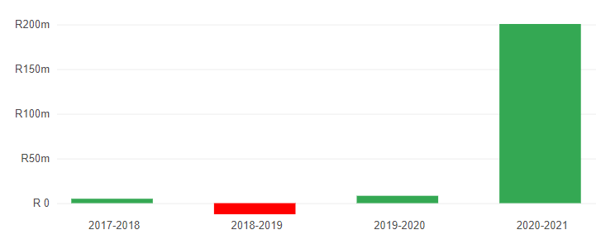
Between 2020 and 2021, Beaufort West has seen an improvement in the cash balance that was available at the end of each financial year. At the end of 2021, the municipality had just over R200 562 591million left over, which is a good indicator.
A municipality's cash balance refers to the money it has in the bank that it can access easily. If a municipality's bank account is in overdraft it has a negative cash balance. Negative cash balances are a sign of serious financial management problems. A municipality should have enough cash on hand from month to month so that it can pay salaries, suppliers and so on.

Cash Coverage
Cash coverage measures the length of time, in months, that a municipality could manage to pay for its day-to-day expenses using just its cash reserves. If a municipality had to rely on its cash reserves to pay all short-term bills, how long could it last? Ideally, a municipality should have at least three months of cash cover and the Beaufort west Municipality had 6.8 months’ worth of cover between 2020 – 2021, which was a good indicator for the period.
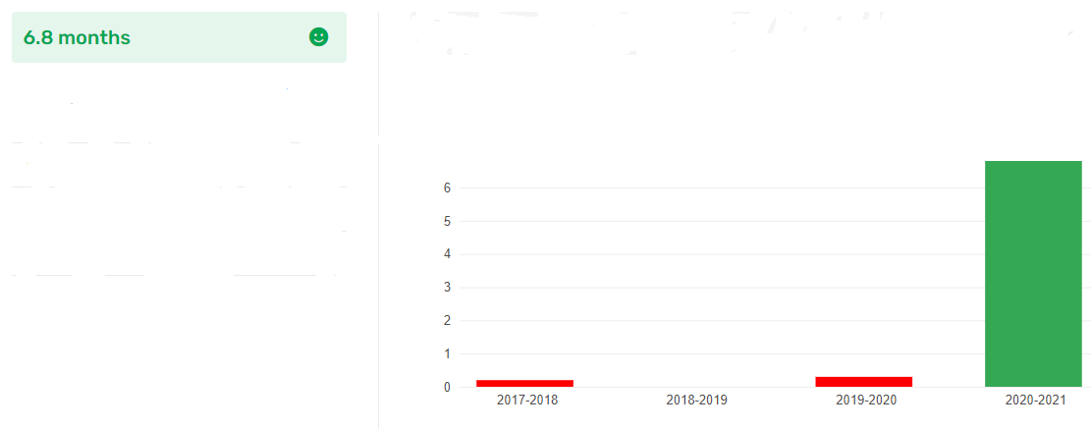

    - Spending of Operating Budget
This indicator is about how much more a municipality spent on its operating expenses, than was planned and budgeted for. It is important that a municipality controls its day-to-day expenses in order to avoid cash shortages. If a municipality significantly overspends its operating budget this is a sign of poor operating controls or something more sinister.
Overspending by up to 5 percent is usually condoned; overspending in excess of 15 percent is a sign of high risk. During 2020 / 2021 the Beaufort West Municipality overspent by 0.9%, which is a good indicator for that specified period.

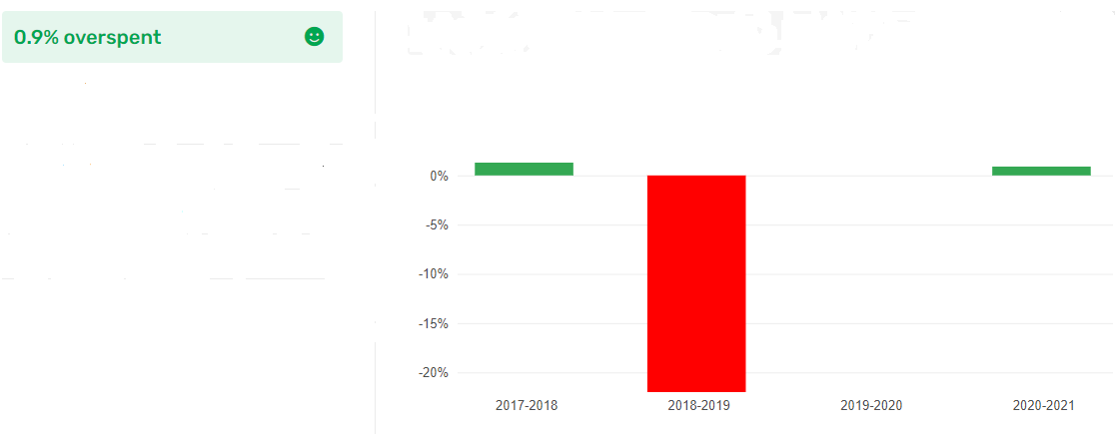
    - Spending of Capital Budget
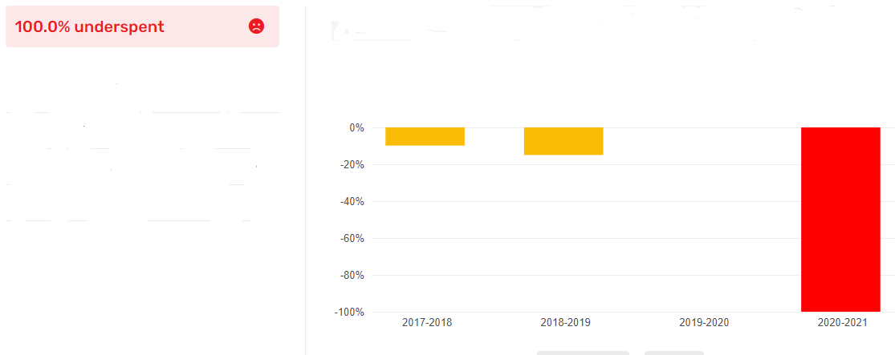
Capital spending includes spending on infrastructure projects like new water pipes or building a library. Underspending on a capital budget can lead to an under-delivery of basic services. This indicator looks at the percentage by which actual spending falls short of the budget for capital expenses. Persistent underspending may be due to under resourced municipalities which cannot manage large projects on time.
Municipalities should aim to spend at least 95 percent of their capital budgets. Failure to spend even 85 percent is a clear warning sign. During 2020 / 2021, the Beaufort West Municipality underspent 100% of its Capital Budget, which was a very bad indicator.

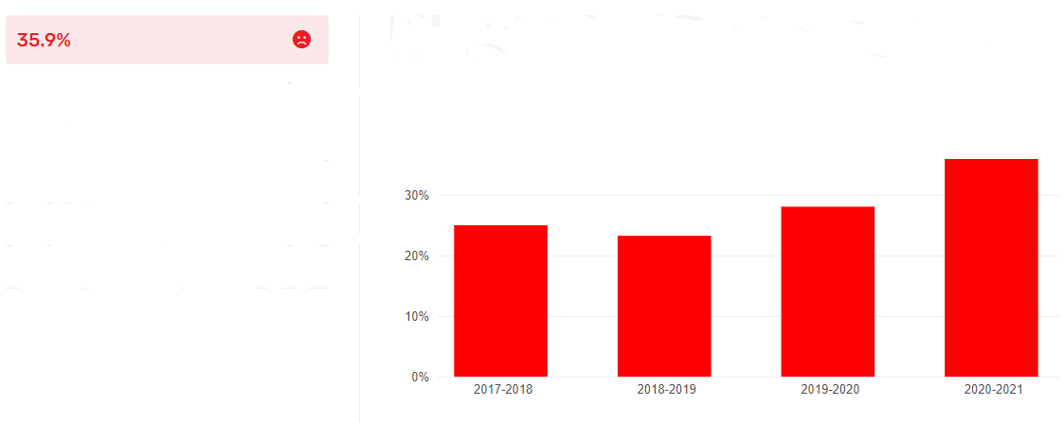
    - Fruitless & Wasteful Expenditure
Fruitless and wasteful expenditure concerns spending which was made in vain and would have been avoided had reasonable care been exercised. An example of such expenditure would include paying a deposit for a venue and not using it and losing the deposit. Beaufort West 35.9% of its operating expenditure of Fruitless and Wasteful Expenditure, which is a bad indicator.

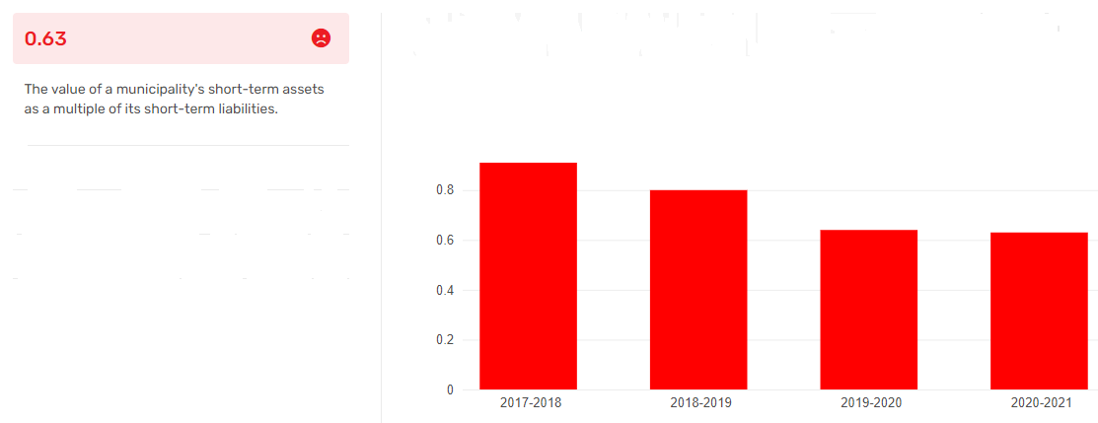
    - Current Ratio
The current ratio compares the value of a municipality's short-term assets (cash, bank deposits, etc) compared with its short-term liabilities (creditors, loans due and so on). The higher the ratio, the better. The normal range of the current ratio is 1.5 to 2 (the municipality has assets more than 1.5 to 2 times its current debts). Anything less than that and the municipality may struggle to keep up with its payments. Beaufort West Municipality’s has always been below 0 from 2017 to 2021, which is a bad indicator.

    - Liquidity Ratio
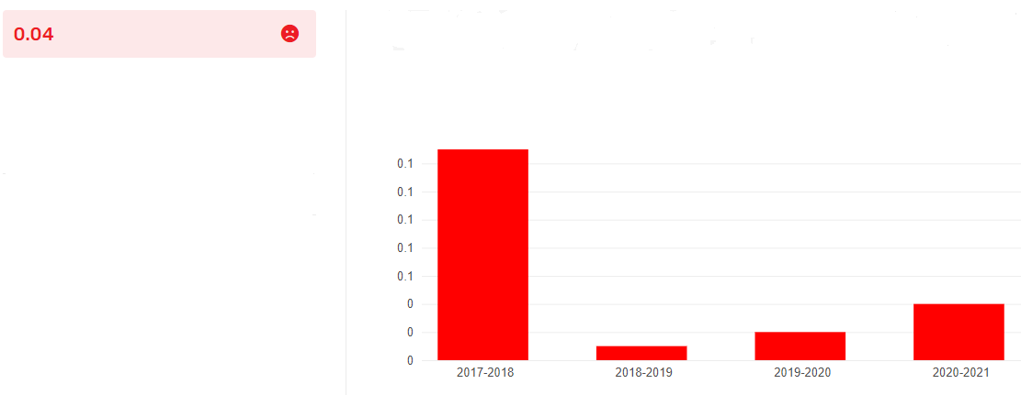
Liquidity ratios show the ability of a municipality to pay its current liabilities (monies it owes immediately such as rent and salaries) as they become due, and their long-term liabilities (such as loans) as they become current.
These ratios also show the level of cash the municipality has and / or the ability it has to turn other assets into cash to pay off liabilities and other current obligations. The liquidity ratios for the Beaufort West Municipality from 2017 – 2021 have always been below 1, which is a bad indicator for the municipality.

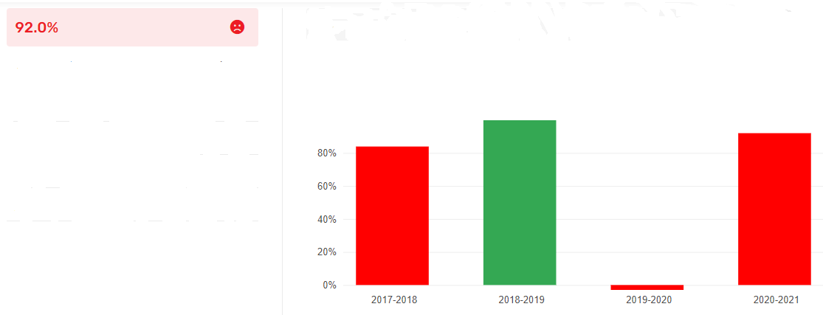
    - Current Debtors Collection Rate
Municipalities don't manage to collect all of the money they earn through rates and service charges. This measure looks at the percentage of new revenue that a municipality collects. It is also referred to as the Current Debtors Collection Ratio. Beaufort West’s percentage of new revenue (generated within the 2020 – 2021 financial year) that the municipality collected was 92,0%, which is a bad indicator.

MUNICIPAL INCOME
The more a municipality is able to generate its own income, the more self-sufficient it is. Municipalities should not be too reliant on transfers and grants from other spheres of government. Beaufort West generated 70,3% of its own money whilst receives 27.7% from the equitable share of taxes and grants from National Government.
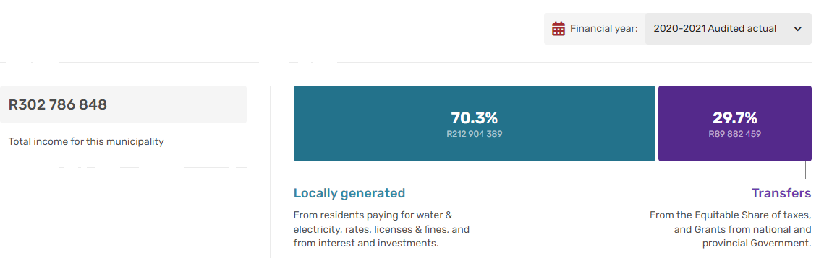

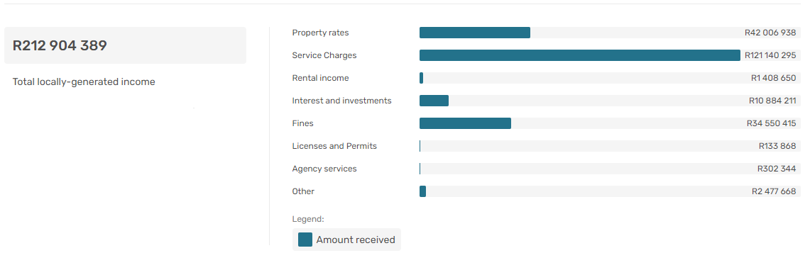
The bar chart above shows how much of a municipality's income it is able to generate itself (through property rates, service charges, etc.)in 2020 / 2021.
  - MUNICIPAL SPENDING
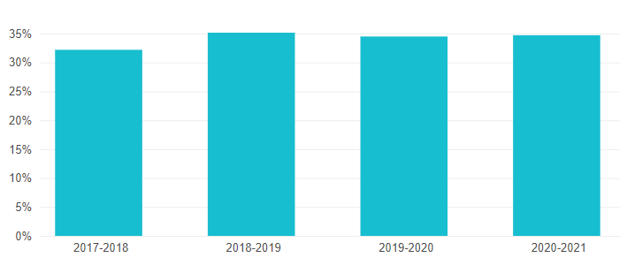
    - Staff Wages and Salaries
Employee-related costs are typically the largest portion of operating expenditure, but they should not grow so large that they threaten the sustainability of the operating budget.
The normal range for this indicator is between 25% - 40% of total operating expenditure. Municipalities must guard against spending too much on staff while also making sure they have the people they need to deliver services effectively.

In 2020 / 2021 Beaufort West spent 34,7% its operating expenditure on staff. The operating expenditure in percentage form towards staff wages or salaries for the period from 2017 – 2021 are illustrated in the chart on the left.

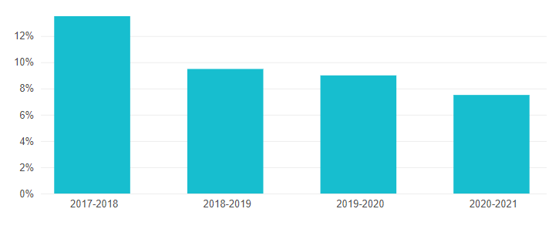
    - Contractor Services
Private contractors are sometimes needed for certain work, but they are usually more expensive than municipal staff. This should be kept to a minimum and efforts should be made to provide services in-house, where possible.
This measure is normally between 2 percent and 5 percent of total operating expenditure.
In 2020 / 2021, Beaufort West spent 7.5% of its operating expenditure on contractor services, which is bad. The percentages of money spent on contractor services from 2017 – 2021 are illustrated in the chart on the left.

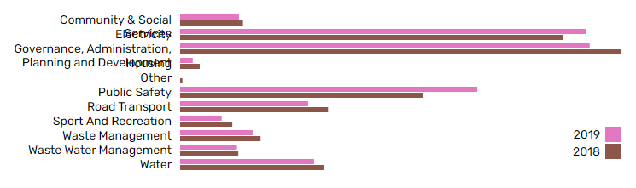
    - What services is money spent on?
In 2018 and 2019, Beaufort West spent their money on the following different municipal services, however the cost of each service is not indicated (see bar chart below):
- Community and Social Services;
- Electricity
- Governance, Administration, Planning and Development
- Planning and Development
- Other
- Public Safety
- Road and Transport
- Sport and Recreation
- Waste Management
- Water

  - A synthesis: financial health, municipal income, and municipal spending
Overall, Beaufort West’s financial position is showing an improving trend between 2017 and 2021 with improved audit outcomes, cash balances, improved cash coverage, spending of operating budget and decreases in underspending of Capital budget, which remains a challenge, as well as fruitless and wasteful expenditure.
The current ratio is satisfactory, as is the liquidity ratio and current debtor’s collection rate.
From an income generation perspective, 70.3% of income is generated from own revenue and 29.7% is from government grants, which is indicative of a municipality largely in control of generating its own income.
Close to 35% of income is spent on wages and salaries which is a risk for the municipality that it should seek to drive downwards to between 25% to 30% of total revenue.
Most service spending goes towards electricity, governance, administration and planning and development as well as roads, housing, and water.

- SECTION 2: LONG TERM FINANCIAL PLAN 2015 KEY FINDINGS AND INFORMANTS
It is noted that the Long-Term Financial Plan (LTFP) for the Beaufort West Municipality is outdated and needs to be reviewed and updated. The plan covers the period between 2010 and 2019. It therefore does not take cognisance of the next ten years in its current form. Once it has been updated latest data, it will also serve as an informant to and informed by the Beaufort West MSDF.

